Creating a Hello World Program

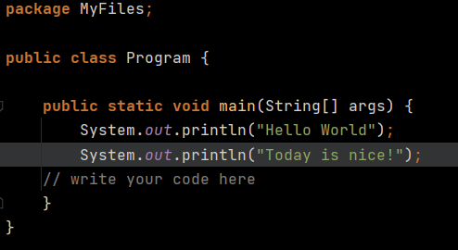

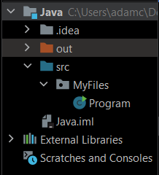

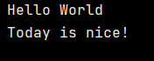

# Data Types:

Before declaring a variable the data type needs to be declared. For example:

Age = 21; Will create an error within the file as java cannot tell what data type this is. Age = X; This does not matter what X is, the error will still persist.

To fix this the data type MUST be declared prior to the variable name:

Int Age = 21; string Name = “Adam”; double LBS = 5.5;

Java reads in the order: Data Type > Variable > Data and will create and error if one of these stages is missed.

# Console Input:

To get console input the scanner function needs to be imported into the file. To do this the import command needs to be used outside of the main java loop like so:

Import java.util.Scanner - \java\utilities\Scanner

To get input an object needs to be created e.g

Scanner input; //declares the type of data

Input = new Scanner(System.in); /creates an object

System.out.printLn(“Enter your age: ”); //Asks the user to enter their age

Int age; //declares variable age

Input.nextInt(); //Gets the integer that the user entered in the console

System.out.prinLn(“You Inputted” + age); //Prints the age the user entered

# Helper Functions: Use with caution

Concept: Something which makes code easier

Helper functions must always be in the same class as the main, Should only ever exist in this class.

Uses static as part of its name.

Purpose: The purpose of a helper function is to wrap code and its mechanics being a new chosen piece of code.

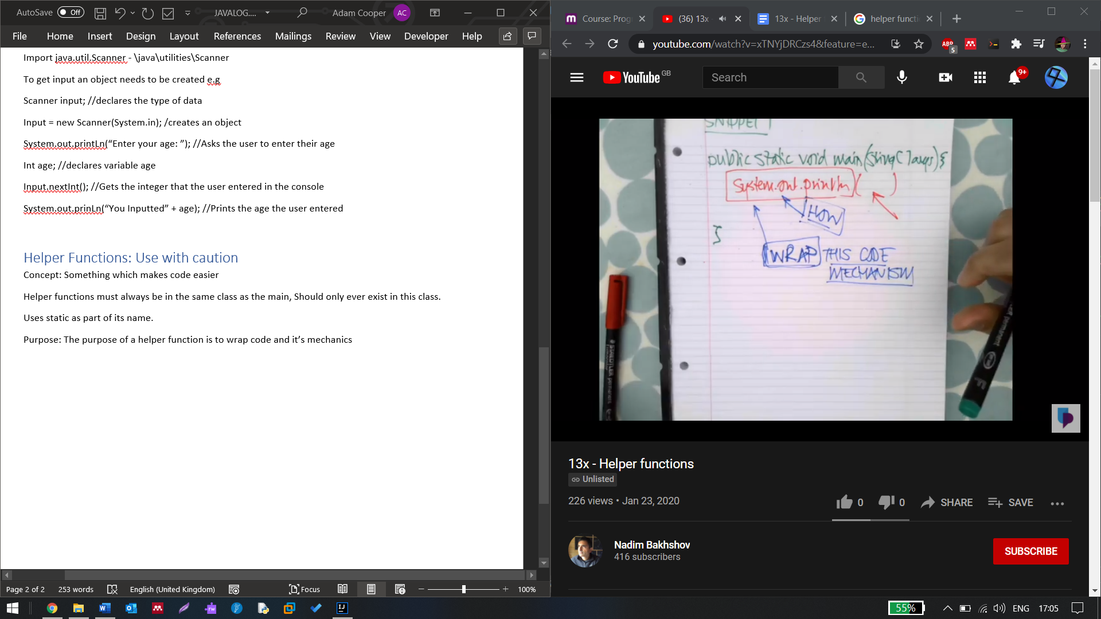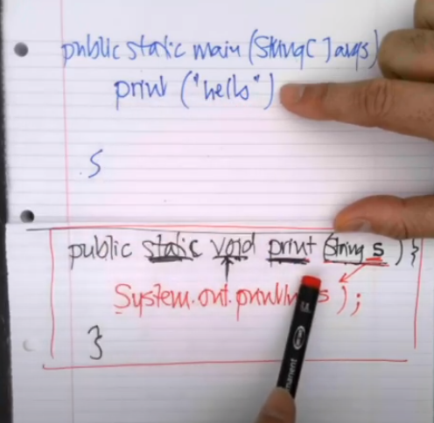

Public static void print (string s){

System.out.printLn(s);

}

This code allows the use of print instead of “System.out.printLn(“”)”

If Statements:

